Operating systems
Lab assignment 1 : shell and systems calls

SheLL For GeeKs

Name :Bassem Mohamed Abdelmoniem
ID : 11

The Content is as following:

- How code is organized
- The main function description
- Sample run
- Screen shoots for process tree

How code is organized:

There are 3 files main.c , parser.c and parser.h:
1- main.c : this contain the main suction of program ,the execution functions and the function of reading and writing to files.
2- parser.c : this contain the function which splits the lines into arguments ,and the function which get the environment variables.

Functions in parser.c :

- void parse(char *tmp_argv,char *my_argv[] , int *background );
- char* attachPath(char* line , char *path );
- void parseEnvVAr(char *env[]);

Main function description:

sudo code to illustrate this:

int main (int argc, char **argv)
{
while (1){
int childPid;
char * cmdLine;

printPrompt();

cmdLine= readCommandLine(); // if (argc == 2) => batch mode read from file

cmd = parseCommand(cmdLine);

if ( isBuiltInCommand(cmd)){
executeBuiltInCommand(cmd);
} else {
childPid = fork();
if (childPid == 0){
executeCommand(cmd); //calls execv

} else {
if (isBackgroundJob(cmd)){

} else {
waitpid (childPid);

}
}
}
}

How to compile and run :

I wrote a script file “Makefile” , here is the code:

gcc -o shell main.c parser.c
./shell input.sh

This code links the 2 files main.c and parser.c throught parser.h.

Sample runs:
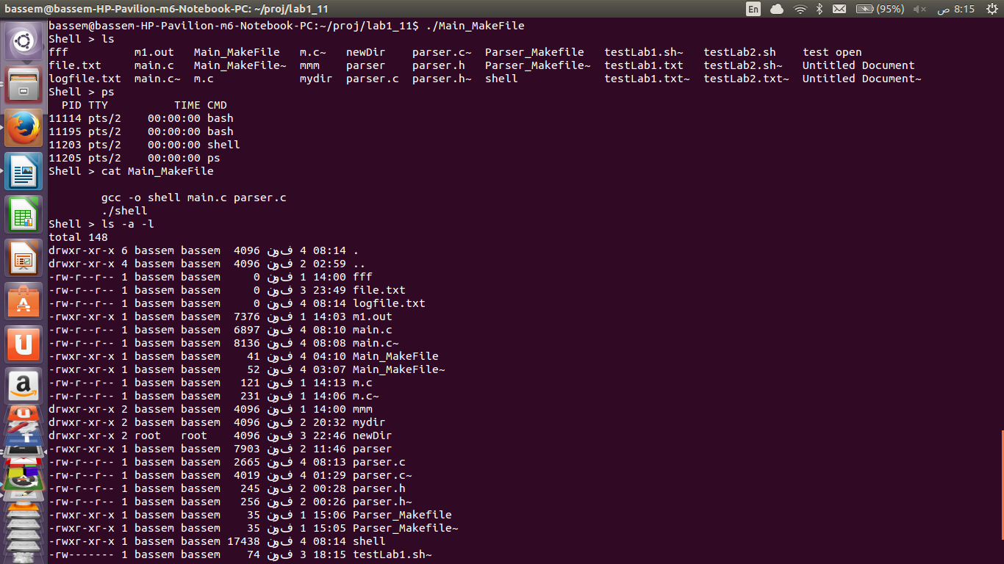

Process tree screen shoots:
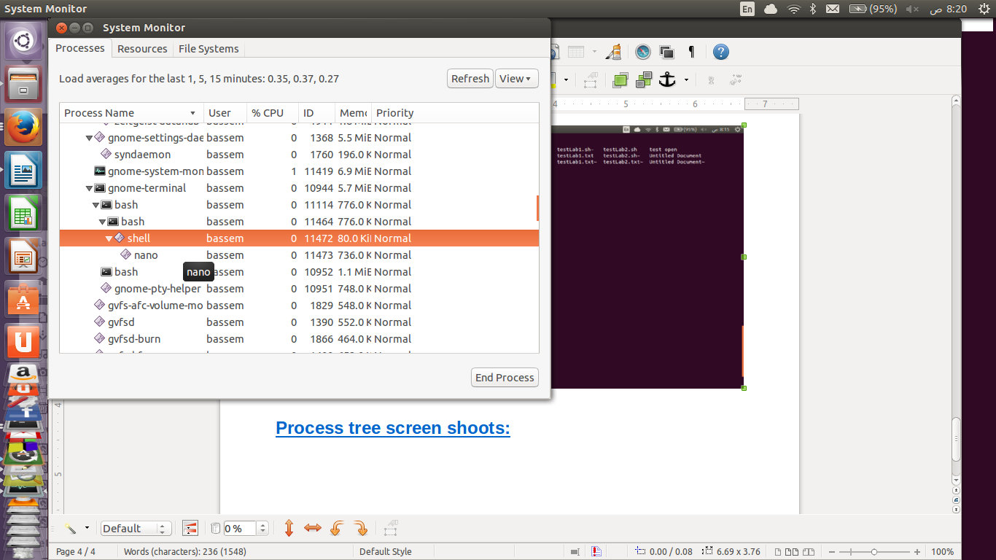
Here nano appears openning under shell

Assumptions

history remembers last 20 commands and use module to replace new with old

